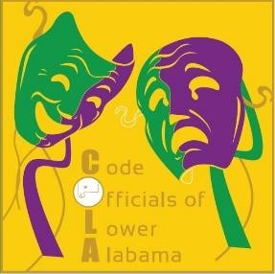

COLA Mid-Winter Conference Vendor Application

Company: _________________________________________________________________

Name/Representative: _________________________________________

Work/Business Address: _____________________________________________________

City: ___________________________ State: ____________ Zip: ____________________

Phone:___________________ Email:___________________________________________
(office or cell number)

COLA Inc. Mid-Winter Conference Vendor fee = $325.00

Make check payable to: Code Officials of Lower Alabama Inc.
P.O. Box 9251
Mobile, AL 36691
(251) 599-0754 / (251) 574-3509 (fax)

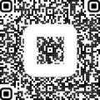

Use link: https://square.link/u/USdj94v7 or use QR code

State of Alabama Accounting and Resource System (STAARS) Vendor Code: VS000089631
-------------------------------------------------- RECEIPT -----------------------------------------------------------------
COLA Mid-Winter Conference Vendor Application

Do you need a table for display? ___ yes ___ no Do you need chair(s) ___ yes – if so, how many? ___
___ no
Any other needs? ___ yes ___ no
Received From: ______________________________________
(Company or Name)
Amount: _________________________
Approved by: ___________
PO/Check#:_____________
Date paid:______________

